2200031128 CH BHAVANA
Handson Task 5 :
- Style a react component
- Define styles using the CSS Module
- Apply styles to components using className and style properties
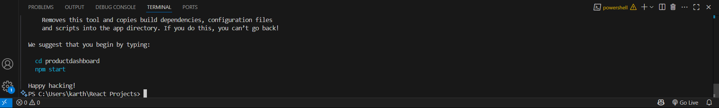
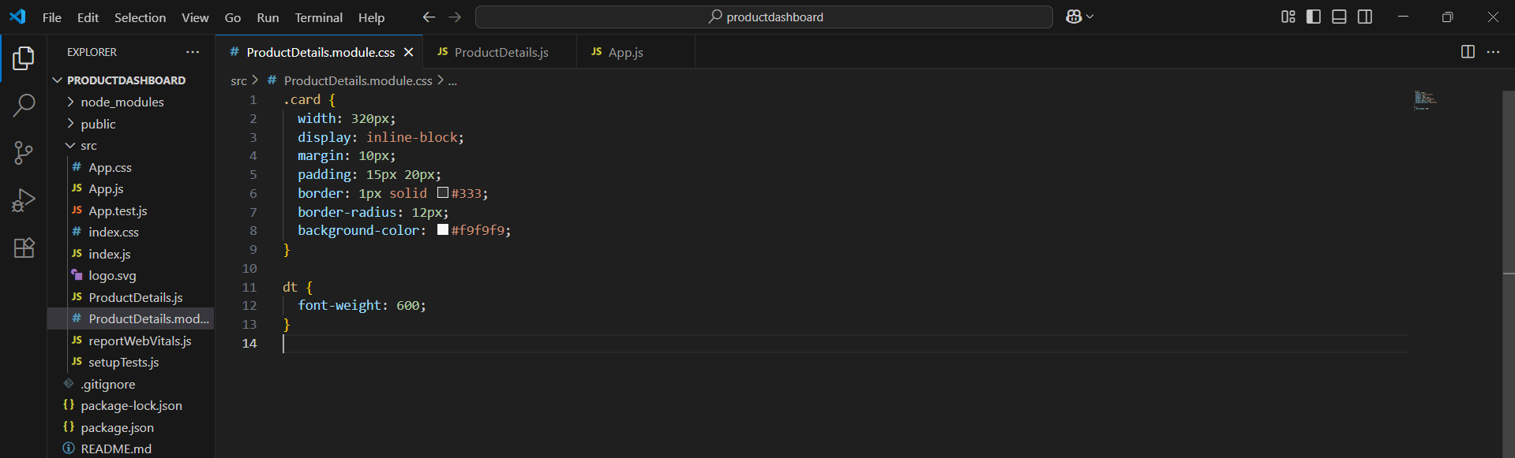
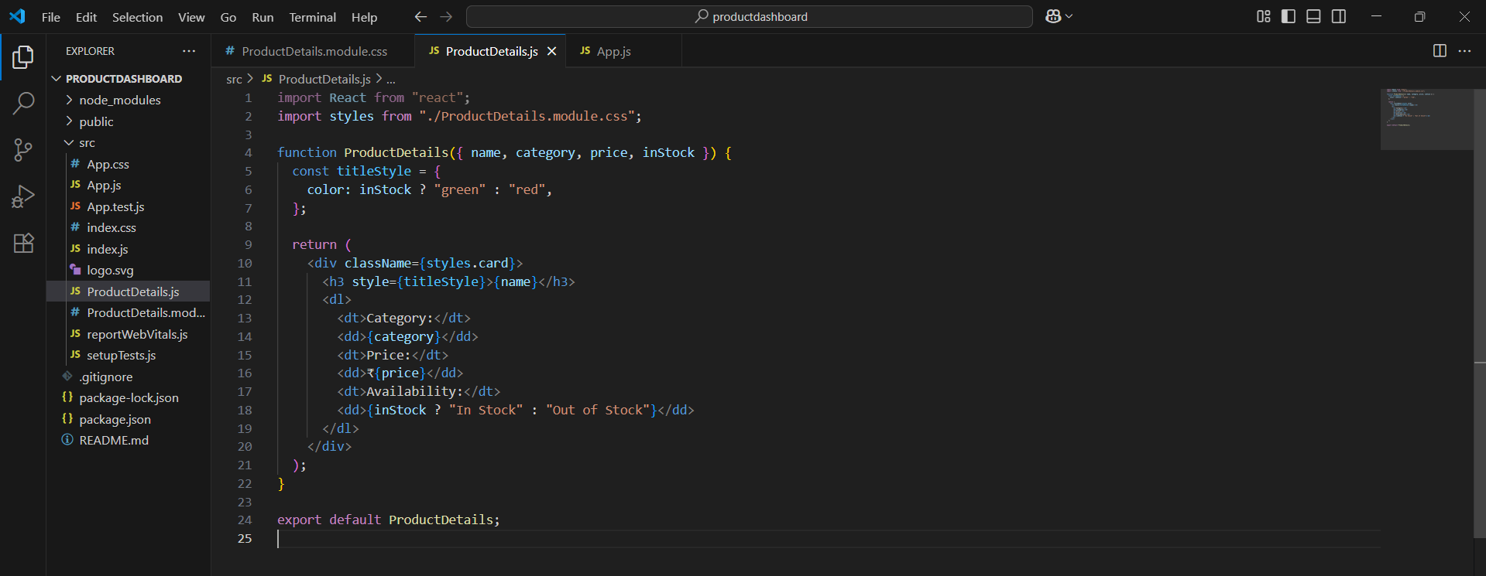
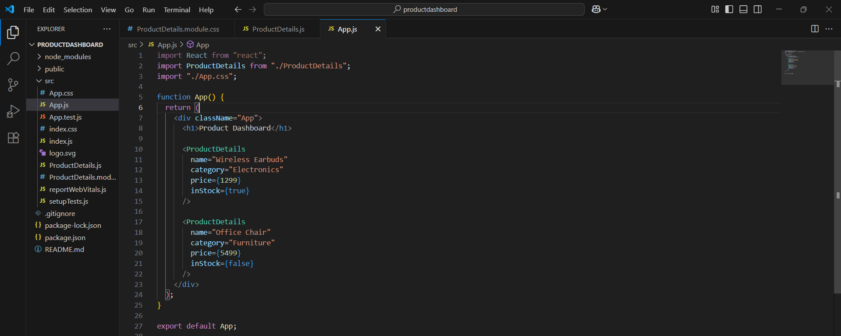
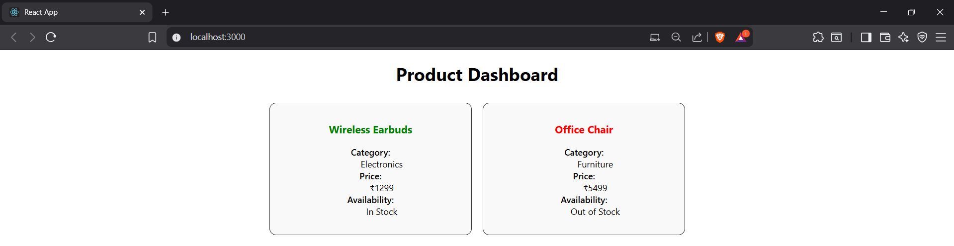
Step 1: Create a new React app using create-react-app
Step 2: Open the app folder and run it using npm start
Step 3: Create a new CSS Module file to define styles (like box, fonts)
Step 4: Create a component to show product details (name, price, category, stock)
Step 5: Use style property to change color based on stock status
(green if in stock, red if out of stock)
Step 6: Apply the CSS module styles using className
Step 7: Import and use the product component in App.js with different products
Step 8: Run the app to see styled product cards on the screen

